Jenkins with Gradle build Steps

1. After installing Gradle and Jenkins open browser and type in the address bar 127.0.0.1:8080
2. Click on new item from the left side of the page.

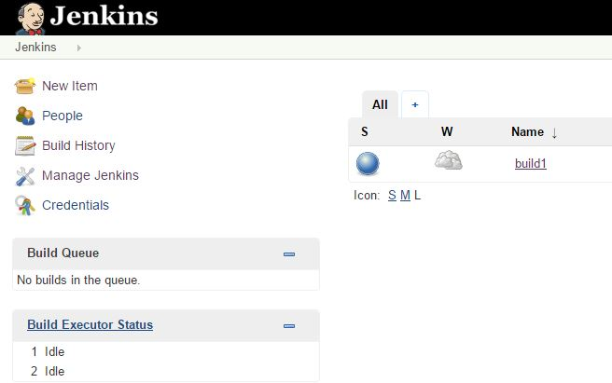

1. Insert the job name say “build1” or whatever you feel like giving that job a name. Choose freestyle project and press ok as shown in the figure.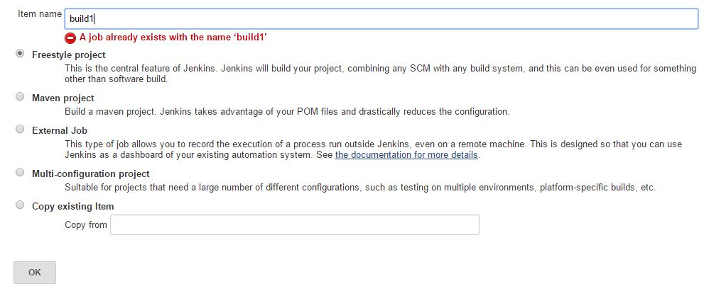
2. In the project configuration scroll down and choose git in Source code management and fill the parameters as shown in the picture. You can use the credentials as you got for git.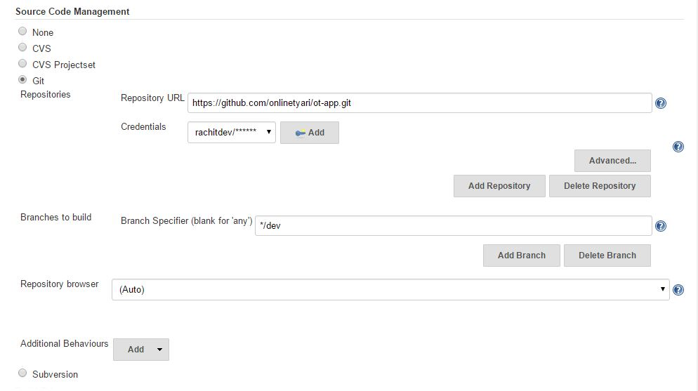
3. Scroll down to build triggers and use the cron job syntax to time the builds. Usually we time it in the nights. So that by the morning we get the test results and we start working on the failed tests. Read cron job syntax for more details by pressing “?” Button besides the text boxes.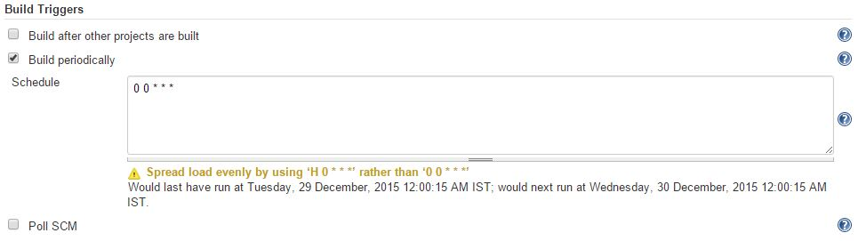
4. Now configure the Gradle plugin according to this pic. You can get the build file path when you test the Git clone in any directory earlier (Important). Don’t Forget to add the task in the Tasks section as it’s the command which will build the apk in the app directory. I am using Gradle and Gradle wrapper as it worked for me. Will use gradle wrapper if required in the later projects.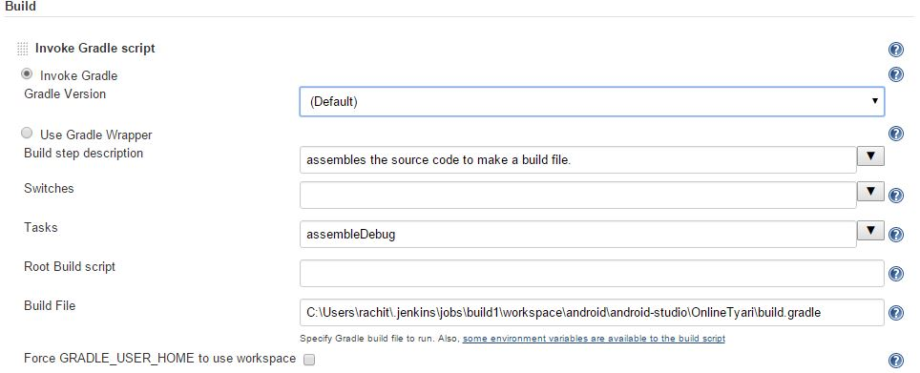
5. Click on save and apply and try building the project.